

**American International University- Bangladesh**

**CSC 3215: Web Technologies**

**CO2 and CO4 Evaluation**

**Finished Project Report**

**Spring/Summer/Fall 2020-2021**

**Project Title: Forseti Management System**

**Section: H**

|  |  |
| --- | --- |
| Student Name | Student Id |
| Aditto Al Ashir | **19-40049-1** |
| Nuhan Islam | **18-37898-2** |
| Saify Abid Bhuiyan | **18-38951-3** |
|  |  |

**Forseti Management System**

**Project Description:**

Through our project we will provide legal aid. If anyone needs a lawyer, they can hire a lawyer using our website. For this he has to go to our website and register. From here he will be able to find a lawyer as per his need and contact him. After receiving legal assistance, he will be able to pay the lawyer's fee. The blockchain method has been used for secure money transactions between users and lawyers. After receiving the full service, the user will be able to give a review to the lawyer and express his opinion about it. Our website has three separate users. They are admin, users and lawyers. The admin can see all the information on the web site. He will be able to change his account information as required. General users of the website and lawyers will also be able to use this feature to correct incorrect information in their accounts. Users or lawyers will also be able to delete their accounts if they wish.

**Project Folder Structure:**

**My project folder structure is given below here:**

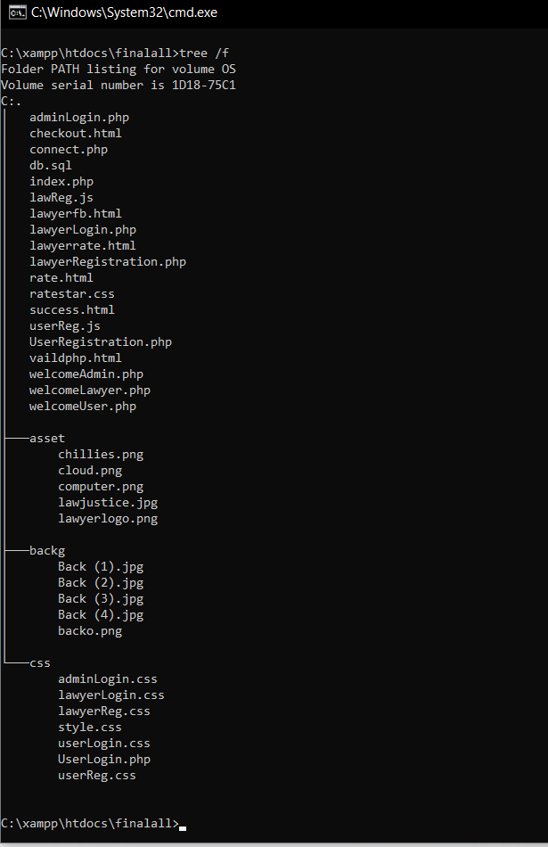

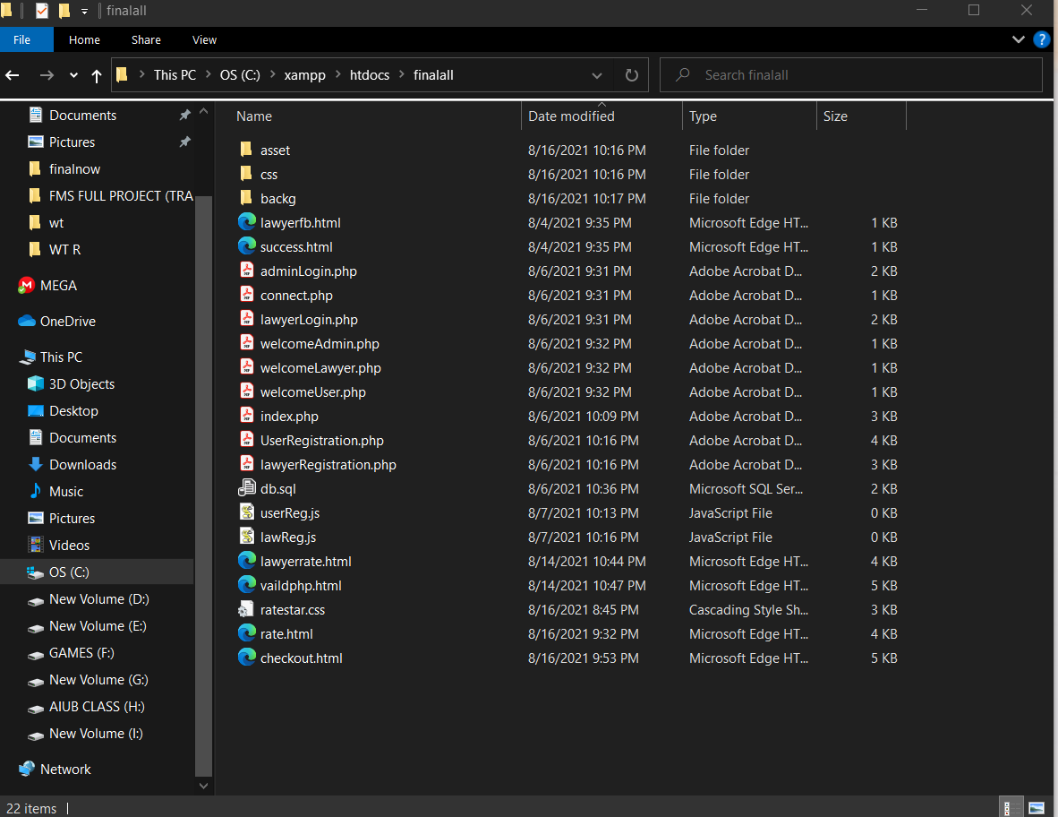

**Core Modules of the Project:**

php validation , Javascript validation , CSS , AJAX , SESSION is used in them

For example:

***SESSION***

<!---------Session------------->

<?php

$userName="admin";

$passWord="admin";

session_start();

if(isset($_SESSION['userName'])){

    echo"<h1>Welcome" .$_SESSION['userName']. "</h1>";

    echo"<a herf='WelcomeAdmin.php'>WelcomeAdmin</a><br>";

    echo"<br> <a href='adminLogin.php'><input type=button value=logout name=logout></a> "

}

else{

    if($_POST['userName']==$userName && $_POST['passWord']==$passWord){

        $_SESSION['userName']=$userName;

        echo"<script>location.herf='welcomeAdmin.php'</script>  "

    }

    else{

        echo"<script>alert('userName or passWord incorrect!')</script>";

        echo"<script>location.herf='adminLogin.php'</script> "

    }

}

?>

***AJAX***

<!--AJAX-->

<script>

   $(document).ready(Function(){

  $('#login').click(function(){

    var username=$('#username').var();

    var password=$('#password').var();

    if($.trim(username).length>0&& $.trim(password).length>0

    {

      $.ajax({

        url:"UserLogin.php",

        method:"POST",

        data:{username:username , password:password},

        cache:false,

        beforeSend:function()

        {

          $('#login'). var("connecting...");

        },

        success:function(data){

          if(data){

            $("body").load("UserLogin.php").hod().fadeIn(1500);

          }

          else{

            var options={

              distance:'40',

              direction:'left',

              time:'3'

            }

            $("#box").effect("Snake",options,800);

            $('#login').var("login");

            $(#'error').html("<span class='text-danger'>Invalid username or Password</span")

          }

        }

      });

    }

  }

}

</Script>

***JAVASCRIPT VALIDATION***

<script type="text/javascript">

function validation()

{

  var username = document.getElementById("USERNAME");

  var password = document.getElementById("PASSWORD")

  if (USERNAME.value =="" ||PASSWORD.value=="")

  {

    alert("Your information is blank");

    return fase;

  }

  else{

    true

  }

</script>

***PHP VALIDATION***

<?php

if($_SERVER["REQUEST_METHOD"] == "POST"){

        $userName = $passWord = "";

        $userNameErr = $passWordErr = "";

    if (empty($_POST["userName"])) {

        $userNameErr = "UserName required";

    }

    else {

        $userName = validateInput($_POST["userName"]);

    }

    if (empty($_POST["passWord"])) {

         $passWordErr = "PassWord required";

    }

    else {

        $lname = validateInput($_POST["passWord"]);

   }

}

    function validateInput($data){

    $data = trim($data);

    $data = stripslashes($data);

    $data = htmlspecialchars($data);

    return $data;

}

1. **Wellcome Page**

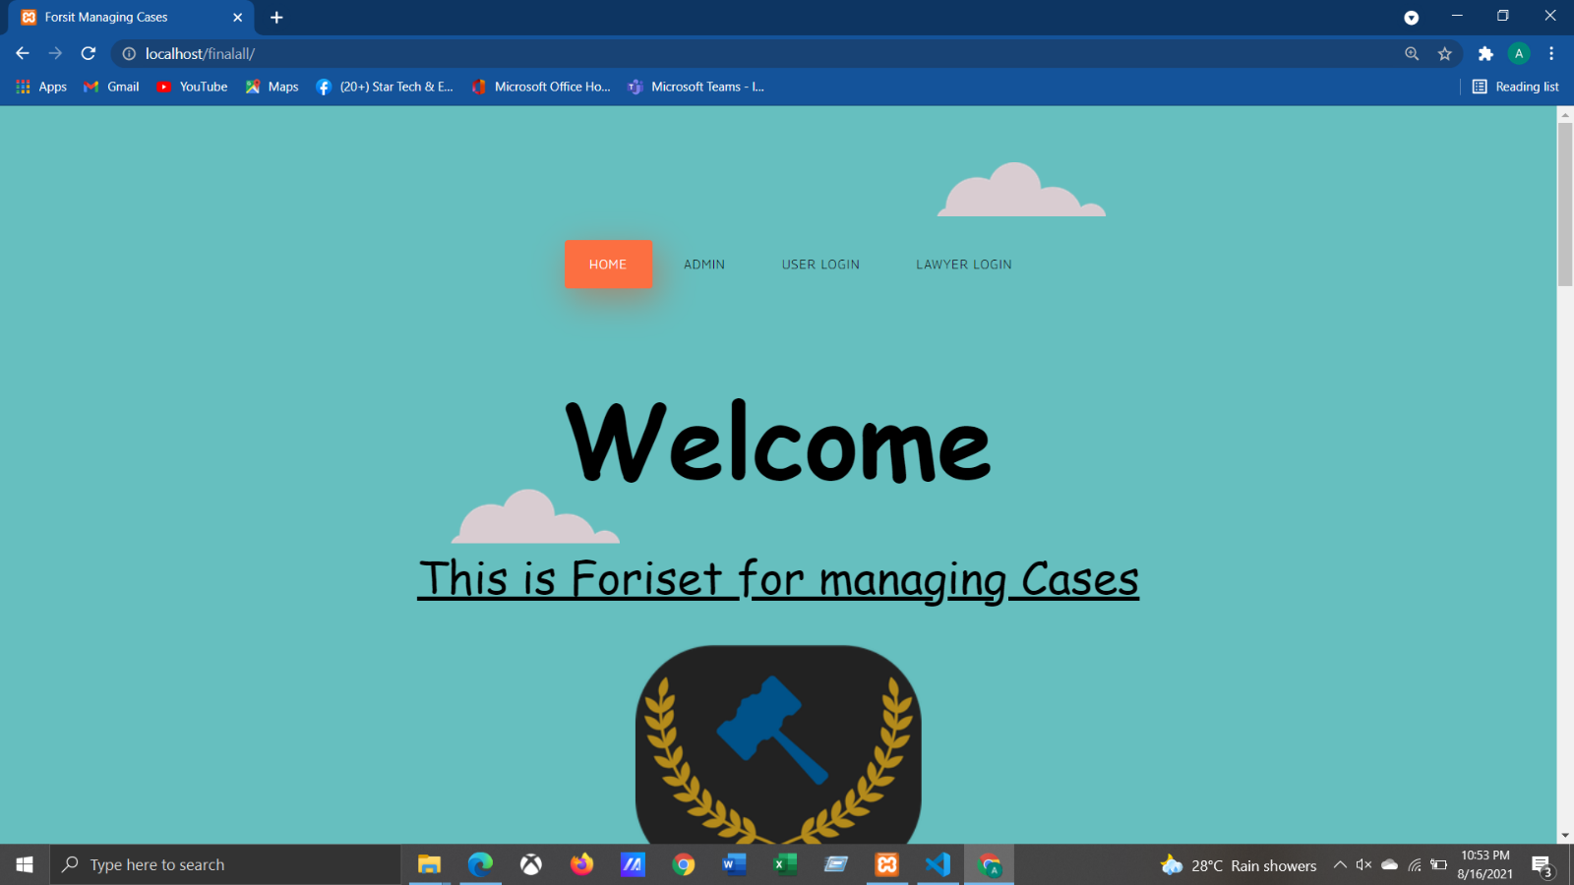

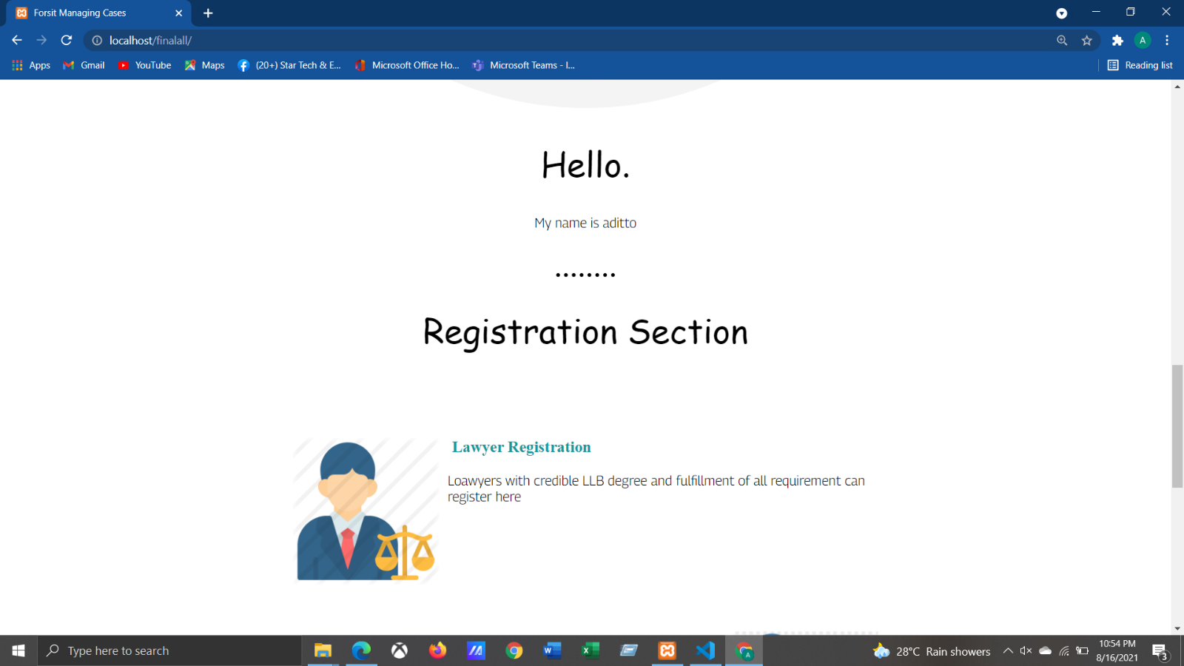

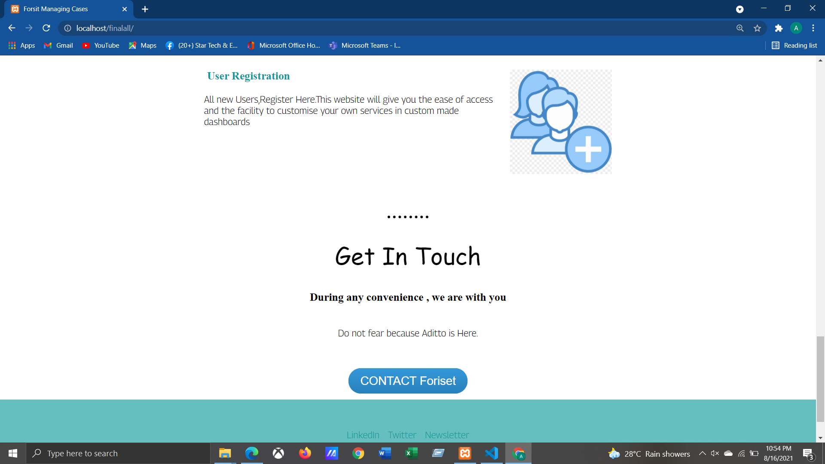

1. **User Login**

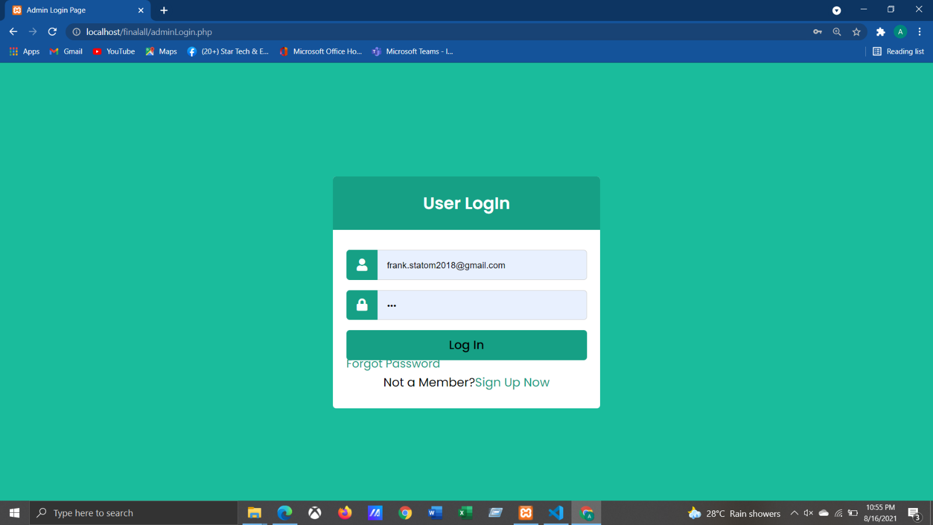

1. **User Registration Form**

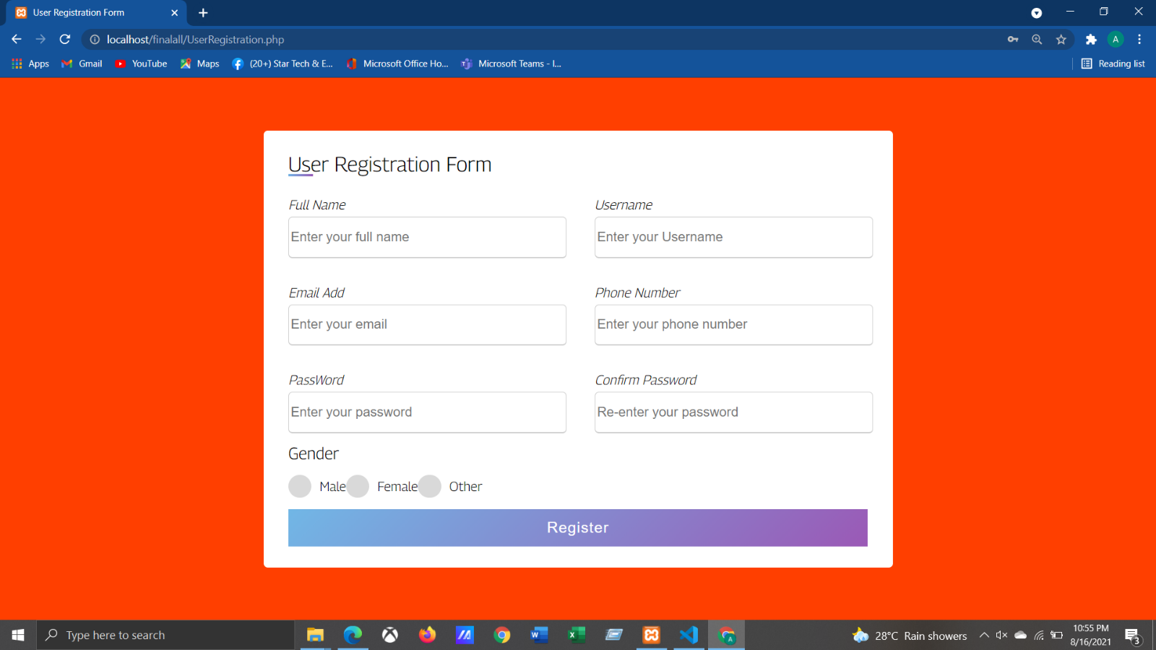

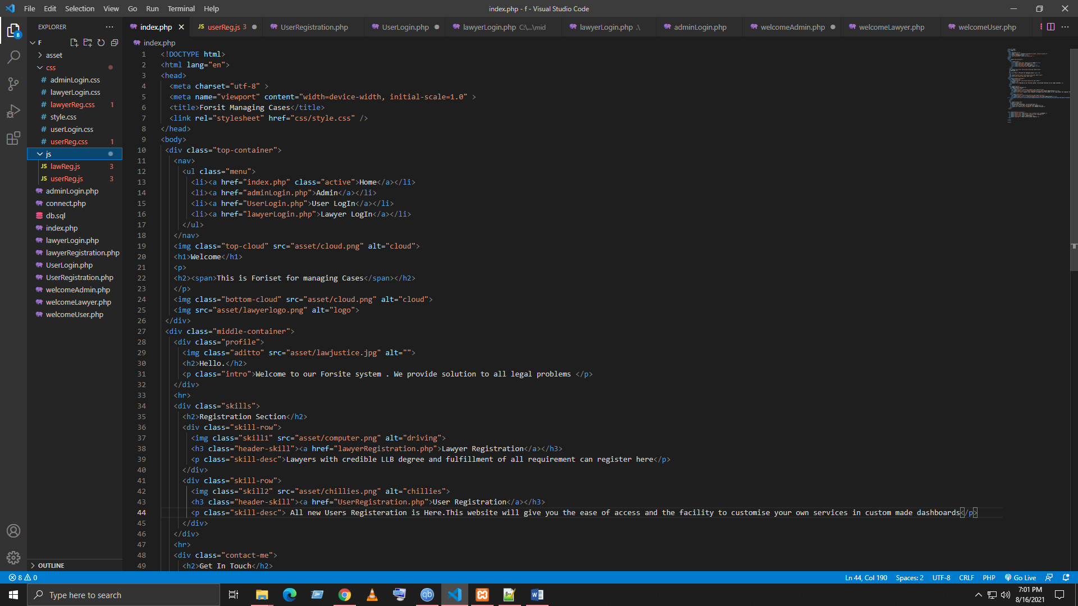

1. **PHP VALIDATION Form**

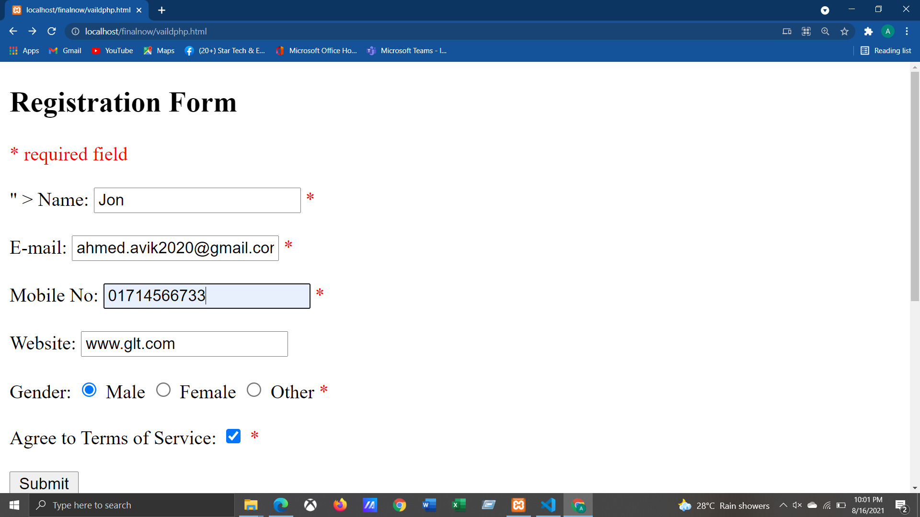

<h2>Registration Form</h2>

<span *class* = "error">* required field </span>

<br><br>

<form *method*="post" *action*="*<*?php echo htmlspecialchars($_SERVER["*PHP_SELF"]);* *?*>" >

    Name:

    <input *type*="text" *name*="name">

    <span *class*="error">* *<*?php echo $nameErr; ?> </span>

    <br><br>

    E-mail:

    <input *type*="text" *name*="email">

    <span *class*="error">* *<*?php echo $emailErr; ?> </span>

    <br><br>

    Mobile No:

    <input *type*="text" *name*="mobileno">

    <span *class*="error">* *<*?php echo $mobilenoErr; ?> </span>

    <br><br>

    Website:

    <input *type*="text" *name*="website">

    <span *class*="error">*<*?php echo $websiteErr; ?> </span>

    <br><br>

    Gender:

    <input *type*="radio" *name*="gender" *value*="male"> Male

    <input *type*="radio" *name*="gender" *value*="female"> Female

    <input *type*="radio" *name*="gender" *value*="other"> Other

    <span *class*="error">* *<*?php echo $genderErr; ?> </span>

    <br><br>

    Agree to Terms of Service:

    <input *type*="checkbox" *name*="agree">

    <span *class*="error">* *<*?php echo $agreeErr; ?> </span>

    <br><br>

    <input *type*="submit" *name*="submit" *value*="Submit">

    <br><br>

</form>

5.Lawyer;s Reviews Output

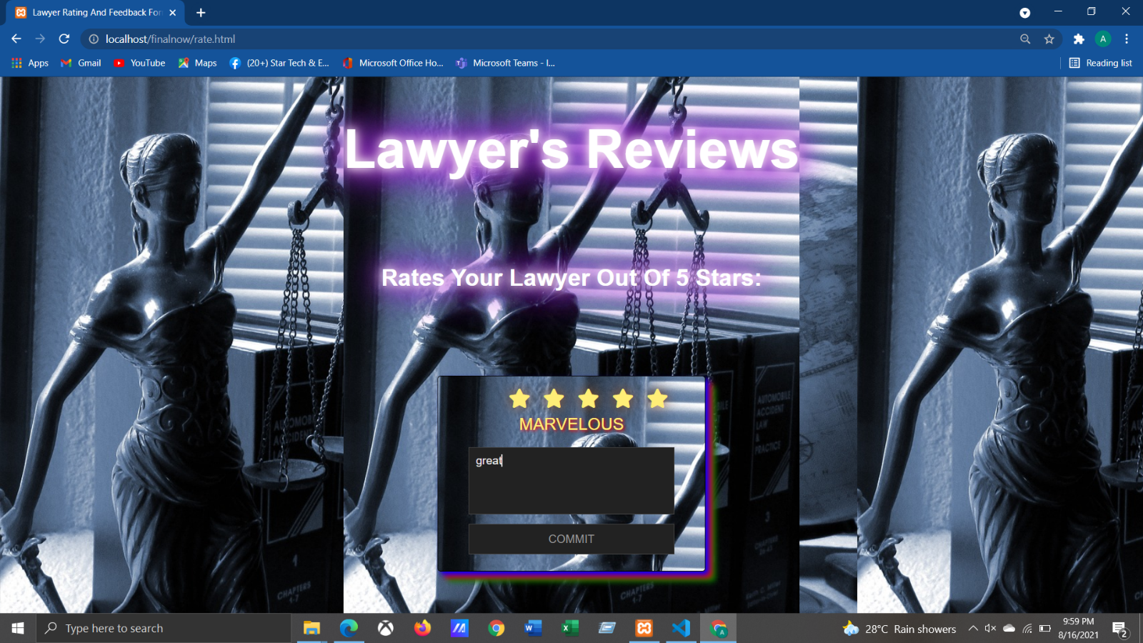

    <div *class*="container">

      <div *class*="post">

        <div *class*="text"> Gratefulness for sharing your feedback and rating with us!</div

        <div *class*="edit">MODIFY</div>

      </div>

      <div *class*="star-widget">

        <input *type*="radio" *name*="rate" *id*="rate-5">

        <label *for*="rate-5" *class*="fas fa-star"></label>

        <input *type*="radio" *name*="rate" *id*="rate-4">

        <label *for*="rate-4" *class*="fas fa-star"></label>

        <input *type*="radio" *name*="rate" *id*="rate-3">

        <label *for*="rate-3" *class*="fas fa-star"></label>

        <input *type*="radio" *name*="rate" *id*="rate-2">

        <label *for*="rate-2" *class*="fas fa-star"></label>

        <input *type*="radio" *name*="rate" *id*="rate-1">

        <label *for*="rate-1" *class*="fas fa-star"></label>

        <form *action*="#">

          <header></header>

          <div *class*="textarea">

            <textarea *cols*="30" *placeholder*="Describe your experience.."></textarea>

          </div>

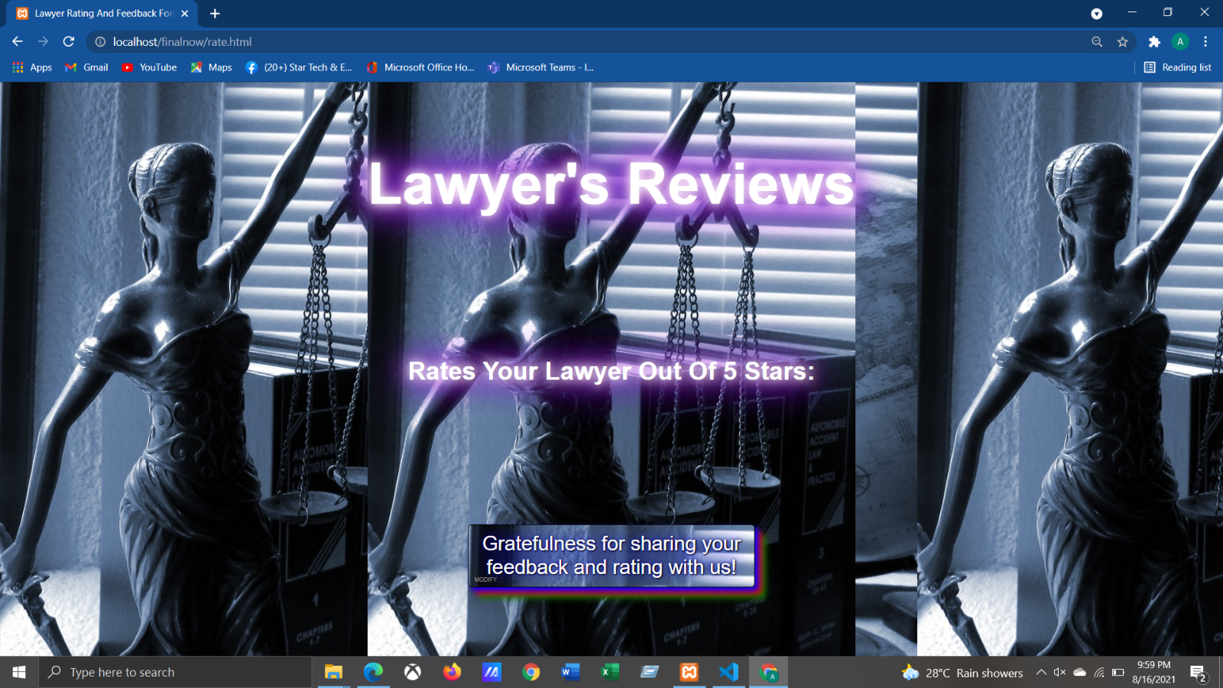

          <div *class*="btn">

            <button *type*="submit">Commit</button>

          </div>

        </form>

      </div>

    </div>

    <script>

      const btn = document.querySelector("button");

      const post = document.querySelector(".post");

      const widget = document.querySelector(".star-widget");

      const editBtn = document.querySelector(".edit");

      btn.onclick = ()=>{

        widget.style.display = "none";

        post.style.display = "block";

        editBtn.onclick = ()=>{

          widget.style.display = "block";

          post.style.display = "none";

        }

        return false;

      }

    </script>

**6.Payment Checkout Form**

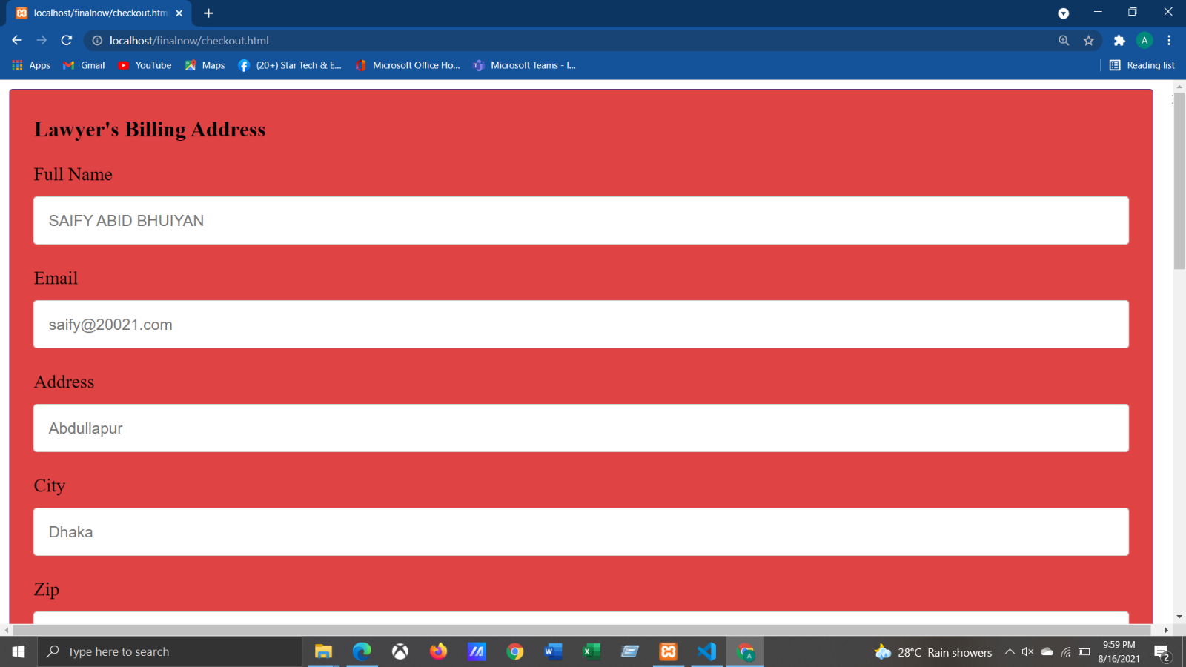

<div *class*="row">

            <div *class*="col-50">

              <h3>Lawyer's Billing Address</h3>

              <label *for*="fname"><i *class*="fa fa-user"></i> Full Name</label>

              <input *type*="text" *id*="fname" *name*="firstname" *placeholder*="SAIFY ABID BHUIYAN"> <br>

              <label *for*="email"><i *class*="fa fa-envelope"></i> Email</label>

              <input *type*="text" *id*="email" *name*="email" *placeholder*="saify@20021.com"> <br>

              <label *for*="adr"><i *class*="fa fa-address-card-o"></i> Address</label>

              <input *type*="text" *id*="adr" *name*="address" *placeholder*="Abdullapur"> <br>

              <label *for*="city"><i *class*="fa fa-institution"></i> City</label>

              <input *type*="text" *id*="city" *name*="city" *placeholder*="Dhaka">    <br>

              <div *class*="row">

                <div *class*="col-50">

                </div>

                <div *class*="col-50">

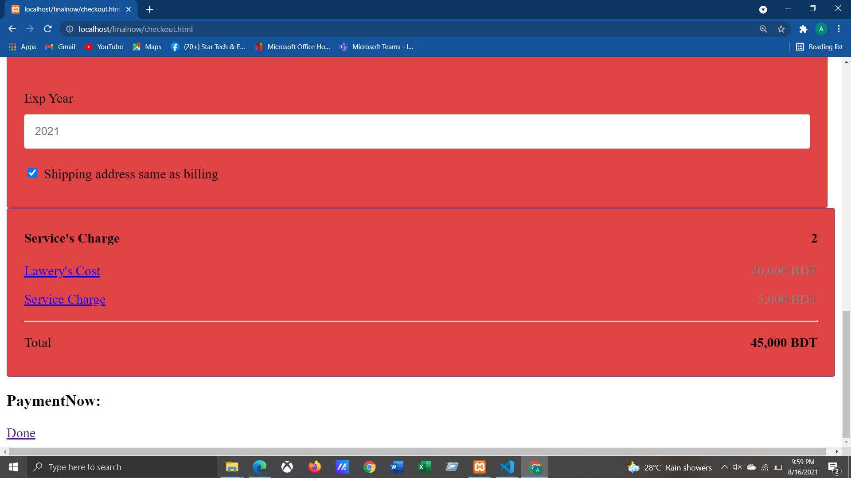

<p><a *href*="#">Lawery's Cost</a> <span *class*="price">40,000 BDT</span></p>

        <p><a *href*="#">Service Charge</a> <span *class*="price">5,000 BDT</span></p>

        <hr>

        <p>Total <span *class*="price" *style*="color:black"><b>45,000 BDT</b></span></p>

**7. Success Message**

<body>

      <div *class*="card">

        <i *class*="checkmark">✓</i>

      </div>

        <h1>Success</h1>

        <p>We received your payment ;<br/> we'll be in touch shortly!</p>

      </div>

    </body>

**Resources:**

1. <https://disruptiveadvertising.com/conversion-rate-optimization/best-lawyer-websites/>
2. <https://www.sitepoint.com/xmlhttprequest-vs-the-fetch-api-whats-best-for-ajax-in-2019/>
3. <https://vlex.com/legal-research/>